### [W3.CSS Templates](https://www.w3schools.com/w3css/w3css_templates.asp)

https://www.w3schools.com/w3css/w3css_templates.asp

[Dịch trang này](https://translate.google.com.vn/translate?hl=vi&sl=en&u=https://www.w3schools.com/w3css/w3css_templates.asp&prev=search)

Well organized and easy to understand Web building tutorials with lots of examples of how to use**HTML**, **CSS**, JavaScript, SQL, PHP, and XML.

Bạn đã truy cập trang này vào ngày 19/03/2017.

### [Responsive Web Design Templates - W3Schools](https://www.w3schools.com/css/css_rwd_templates.asp)

https://www.w3schools.com/css/css_rwd_templates.asp

[Dịch trang này](https://translate.google.com.vn/translate?hl=vi&sl=en&u=https://www.w3schools.com/css/css_rwd_templates.asp&prev=search)

Well organized and easy to understand Web building tutorials with lots of examples of how to use**HTML**, **CSS**, JavaScript, SQL, PHP, and XML.

Bạn đã truy cập trang này vào ngày 19/03/2017.

### [Download 2515 Free Website Templates - CSS & HTML | Free CSS](http://www.free-css.com/free-css-templates)

www.free-css.com/free-css-templates

[Dịch trang này](https://translate.google.com.vn/translate?hl=vi&sl=en&u=http://www.free-css.com/free-css-templates&prev=search)

The free website **templates** that are showcased here are open source, creative commons or totally free. These free **CSS HTML templates** can be freely ...

‎[Free CSS](http://www.free-css.com/search) · ‎[Free CSS Layouts Page 1](http://www.free-css.com/free-css-layouts/page1) · ‎[J.Klimt Portfolio Free CSS ...](http://www.free-css.com/free-css-templates/page206/j.klimt-portfolio) · ‎[Ambixo](http://www.free-css.com/free-css-templates/page209/ambixo-free)

Bạn đã truy cập trang này vào ngày 19/03/2017.

### [Free CSS | 2515 Free Website Templates, CSS Templates and Open ...](http://www.free-css.com/)

www.free-css.com/

[Dịch trang này](https://translate.google.com.vn/translate?hl=vi&sl=en&u=http://www.free-css.com/&prev=search)

Free **CSS** has 2515 free website **templates**, all **templates** are free **CSS templates**, open ... All of the**templates** have been built using **CSS** & **HTML** or XHTML.

Bạn đã truy cập trang này vào ngày 19/03/2017.

### [Top 16 Free HTML5 & CSS3 Contact Form Templates 2017 - Colorlib](https://colorlib.com/wp/free-html5-contact-form-templates/)

https://colorlib.com/wp/free-html5-contact-form-templates/

[Dịch trang này](https://translate.google.com.vn/translate?hl=vi&sl=en&u=https://colorlib.com/wp/free-html5-contact-form-templates/&prev=search)

4 thg 1, 2017 - Adding these **templates** to your pages will be incredibly easy, as easy as having to create a few **HTML** and **CSS** files and then specify their ...

### [Free HTML5 CSS Website Templates](http://www.templatemo.com/)

www.templatemo.com/

[Dịch trang này](https://translate.google.com.vn/translate?hl=vi&sl=en&u=http://www.templatemo.com/&prev=search)

You can download free HTML5 **CSS** website **templates**, responsive Bootstrap layouts from templatemo.

### [Free HTML5 CSS Website Templates - Page 1 - Templatemo](http://www.templatemo.com/page/1)

www.templatemo.com/page/1

[Dịch trang này](https://translate.google.com.vn/translate?hl=vi&sl=en&u=http://www.templatemo.com/page/1&prev=search)

Download free HTML5 **CSS** web **templates** and responsive Bootstrap themes to use for any purpose. Page 1.

### [Free HTML CSS Website Templates](http://www.tooplate.com/)

www.tooplate.com/

[Dịch trang này](https://translate.google.com.vn/translate?hl=vi&sl=en&u=http://www.tooplate.com/&prev=search)

Download free **HTML CSS** website **templates** and use them for any purpose. Our **templates** are easy to edit and apply for your websites.

### [66 Free Responsive HTML5 CSS3 Website Templates 2017](https://dcrazed.com/free-responsive-html5-css3-templates/)

https://dcrazed.com › Website Templates › HTML5

[Dịch trang này](https://translate.google.com.vn/translate?hl=vi&sl=en&u=https://dcrazed.com/free-responsive-html5-css3-templates/&prev=search)

6 thg 2, 2017 - With bootstrap as its core **css** style, this new **html** landing page **template** is very sleek in looks and performance. The fixed backgrounds, full ...

### [Free html css templates free website templates for free download ...](http://all-free-download.com/free-website-templates/free-html-css-templates.html)

all-free-download.com/free...templates/free-html-css-templates.html

[Dịch trang này](https://translate.google.com.vn/translate?hl=vi&sl=en&u=http://all-free-download.com/free-website-templates/free-html-css-templates.html&prev=search)

We have about (109) free **html css templates** free website **templates** in **css**, **html**, js format. free**html css templates**, free **templates** using **html css** javascript, ...

### [Site Templates - HTML Website Templates from ThemeForest](https://themeforest.net/category/site-templates)

https://themeforest.net/category/site-templates

[Dịch trang này](https://translate.google.com.vn/translate?hl=vi&sl=en&u=https://themeforest.net/category/site-templates&prev=search)

Choose from over 10000 **HTML** Website **Templates** on ThemeForest. Buy **Templates** from $5 on the #1 marketplace for Website **Templates**. ... **css3** 1,034.

### [HTML5 UP! Responsive HTML5 and CSS3 Site Templates](https://html5up.net/)

https://html5up.net/

[Dịch trang này](https://translate.google.com.vn/translate?hl=vi&sl=en&u=https://html5up.net/&prev=search)

Responsive HTML5 and **CSS3** site **templates** designed by @ajlkn.

### [250+ Free Responsive HTML5 CSS3 Website Templates ...](https://www.freshdesignweb.com/free-html5-css3-templates/)

https://www.freshdesignweb.com › Website Templates › HTML5

[Dịch trang này](https://translate.google.com.vn/translate?hl=vi&sl=en&u=https://www.freshdesignweb.com/free-html5-css3-templates/&prev=search)

13 thg 3, 2017 - Ubusina is a new free business responsive **template** built with HTML5, **CSS3** & Bootstrap framework. This free **html templates** is extremely ...

### [CSS Templates (Page 1 of 46) - Free Web Templates](https://www.freewebtemplates.com/css-templates/)

https://www.freewebtemplates.com/css-templates/

[Dịch trang này](https://translate.google.com.vn/translate?hl=vi&sl=en&u=https://www.freewebtemplates.com/css-templates/&prev=search)

Results 1 - 12 of 552 - **CSS templates** are designs that use **CSS** (Cascading StyleSheets) not ... cleanly separates your content (ie. your **HTML**) from the way it's to ...

### [Free Website Templates Page 1 of 28 (Total of 251 Templates) | OS ...](http://www.os-templates.com/free-website-templates)

www.os-templates.com/free-website-templates

[Dịch trang này](https://translate.google.com.vn/translate?hl=vi&sl=en&u=http://www.os-templates.com/free-website-templates&prev=search)

Free Website **Templates** (251 **Templates**) That Can Be Downloaded From Within The OS **Templates**Website. ... Premium & Free Website **Templates** - **CSS** / (X)**HTML** + PSD. Premium Website ...**Template** Type: **CSS** & HTML5 / Responsive.

### [Free web templates, HTML5 and CSS layouts - Just Free Templates](http://www.justfreetemplates.com/web-templates)

www.justfreetemplates.com/web-templates

[Dịch trang này](https://translate.google.com.vn/translate?hl=vi&sl=en&u=http://www.justfreetemplates.com/web-templates&prev=search)

Just input your content and upload! This section has a range of free **css** web **templates** and web designs written in both **HTML** and XHTML with **CSS** to download ...

### [Css3templates.co.uk](http://www.css3templates.co.uk/templates.html)

www.css3templates.co.uk/templates.html

[Dịch trang này](https://translate.google.com.vn/translate?hl=vi&sl=en&u=http://www.css3templates.co.uk/templates.html&prev=search)

Free **CSS3 Templates** to download. Free HTML5 **Templates** to download.

### [Free HTML Website Templates - Freebiesbug](http://freebiesbug.com/code-stuff/html-website-templates/)

freebiesbug.com › Code stuff

[Dịch trang này](https://translate.google.com.vn/translate?hl=vi&sl=en&u=http://freebiesbug.com/code-stuff/html-website-templates/&prev=search)

4 ngày trước - A curated collection of free **HTML**/**CSS** website **templates** ready to be used.

### [Free HTML CSS Web Element Templates - W3layouts](https://w3layouts.com/free-web-elements/)

https://w3layouts.com/free-web-elements/

[Dịch trang này](https://translate.google.com.vn/translate?hl=vi&sl=en&u=https://w3layouts.com/free-web-elements/&prev=search)

Free **HTML CSS** Web Element **Templates** which are free and Responsive download and integrate this free web elements like registration forms, Login Forms, ...

# **2515 FREE WEBSITE TEMPLATES**

* « Latest
* 1
* [2](http://www.free-css.com/free-css-templates?start=12)
* [3](http://www.free-css.com/free-css-templates?start=24)
* [4](http://www.free-css.com/free-css-templates?start=36)
* [5](http://www.free-css.com/free-css-templates?start=48)
* [6](http://www.free-css.com/free-css-templates?start=60)
* [7](http://www.free-css.com/free-css-templates?start=72)
* …
* [209](http://www.free-css.com/free-css-templates?start=2496)
* [210](http://www.free-css.com/free-css-templates?start=2508)
* [Older »](http://www.free-css.com/free-css-templates?start=12)
* 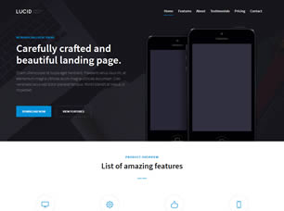
* 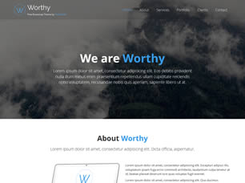
* 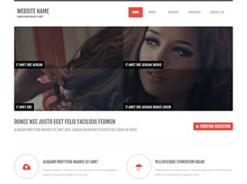
* 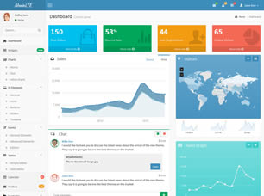
* 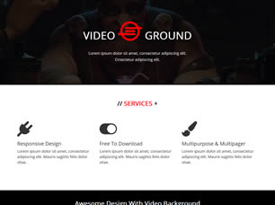
* 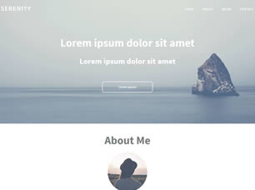
* 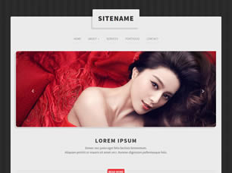
* 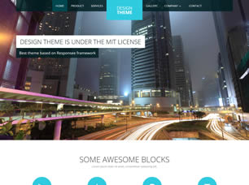
* 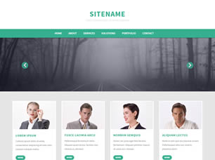
* 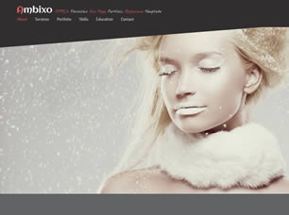
* 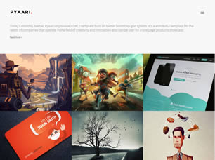
* 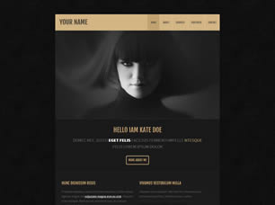
* « Latest
* 1
* [2](http://www.free-css.com/free-css-templates?start=12)
* [3](http://www.free-css.com/free-css-templates?start=24)
* [4](http://www.free-css.com/free-css-templates?start=36)
* [5](http://www.free-css.com/free-css-templates?start=48)
* [6](http://www.free-css.com/free-css-templates?start=60)
* [7](http://www.free-css.com/free-css-templates?start=72)
* …
* [209](http://www.free-css.com/free-css-templates?start=2496)
* [210](http://www.free-css.com/free-css-templates?start=2508)
* [Older »](http://www.free-css.com/free-css-templates?start=12)



We were asked if we could build an overview of all the free website templates that are featured in the Free CSS website, with the latest templates shown first, here it is.

Please note: once inside the main template section the system hasn't changed, so if any confusion arises please [let us know](http://www.free-css.com/contact-us), this is an experimental function and will only stay if feedback is good.

## **LATEST FREE CSS TEMPLATES**

* 
* 
* 

## **WHAT'S ON OFFER**

* [**FREE CSS TEMPLATES**](http://www.free-css.com/free-css-templates)
* Why not download 2515 free website templates. All of the templates have been built using CSS & HTML or XHTML
* [**PREMIUM CSS TEMPLATES**](http://www.free-css.com/commercial-templates)
* If you can't find a free CSS website template that suits your needs, then why not take a look at the premium templates here.
* [**FREE CSS LAYOUTS**](http://www.free-css.com/free-css-layouts)
* We have tons of website layouts ready for download, sometimes mistaken for CSS templates due to the name.
* [**FREE CSS MENUS**](http://www.free-css.com/free-css-menus)
* A wide range of CSS based menus ready for you to download and use in your next project.
* [**FREE CSS REFERENCE**](http://www.free-css.com/css-reference/css1-properties)
* A reference for all the standard CSS mark-up that you will need to modify the templates, layouts & menus' here.
* [**FREE CSS RESOURCES**](http://www.free-css.com/free-css-resources)
* Tons of links to help you find what you are looking for when it comes to CSS and website templates.

###### **OUR SPONSORS**





## **FREE CSS.COM**

Free CSS has 2515 free website templates coded using HTML & CSS in its gallery. The HTML website templates that are showcased on Free CSS.com are the best that can be found in and around the net.

We would personally like to thank all of the website template designers and developers for all of their hard work in creating these free website templates. Without them Free CSS would probably not exist.

Free CSS Admin

# **Top 16 Free HTML5 & CSS3 Contact Form Templates 2017**

* January 4, 2017
* [Alex Ivanovs](https://colorlib.com/wp/author/alexivanovs/)
* [Website Templates](https://colorlib.com/wp/category/website-templates/)
* [12 Comments](https://colorlib.com/wp/free-html5-contact-form-templates/#view_comments)

Customer feedback, day to day communication between webmasters, support questions, general feedback, and so many other types of communication we find on websites rely on a functional contact form to allow for this back and forth communication to happen in the first place. While it’s possible to just mention your email address here and there, a contact form is a much more solid (and convenient) concept of allowing others to reach out to you, and your business. Be mindful of the possibilities of internet based communication, and use a proper contact form that’s easy to access and use — we will help you with the templates to choose from.

There are so many benefits for using a contact form. First up, we are eliminating a significant portion of spam related emails to our inbox as instead of displaying plain email address (which spammers can easily decipher), we are using a dynamic form that can be secured using hardened captcha plugins and tools. Then we move on to being able to ask from customers the kind of things we want to learn more about them, for example — design companies might want to ask the customers their budget, or the kind of field they are working in to be better able to categorize each email, and each potential client. And then there is the consistency of usability. Contact forms make it easy to receive and reply to emails, as most of the time they all have the same feel and look.

While blogging platforms like Drupal and WordPress provide its users with a ton of exciting contact form plugins, those of us who rely on building our own websites will naturally need to rely on contact form templates, and in today’s list we are exploring the best free HTML5 and CSS3 contact form templates that will add some real personality, and feel of modernization to your contact pages. Adding these templates to your pages will be incredibly easy, as easy as having to create a few HTML and CSS files and then specify their location.

## **Colorlib Contact Form**

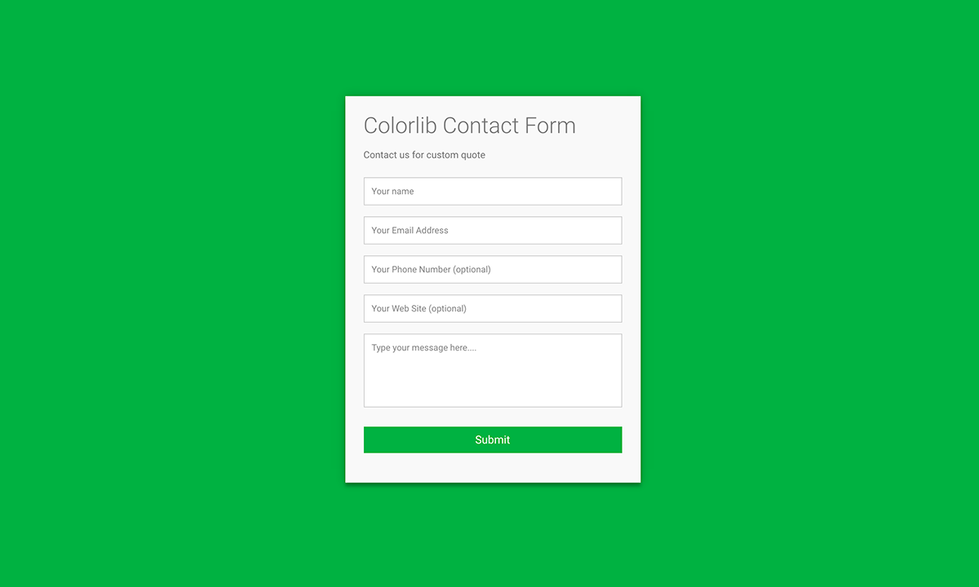

With such intense amount of frameworks available to the developer crowd nowadays, it can sometimes be tough to find native forms built from scratch, but this one is exactly that. A native HTML5, and CSS3 contact form that’s compact, easy to customize to your own needs, and only requires a simple dynamic configuration for sending the actual emails through. Styling can be configured according to your own requirements.

[Download](http://codepen.io/colorlib/pen/KVoZyv)

## **Bootstrap 3 Contact form with Validation**

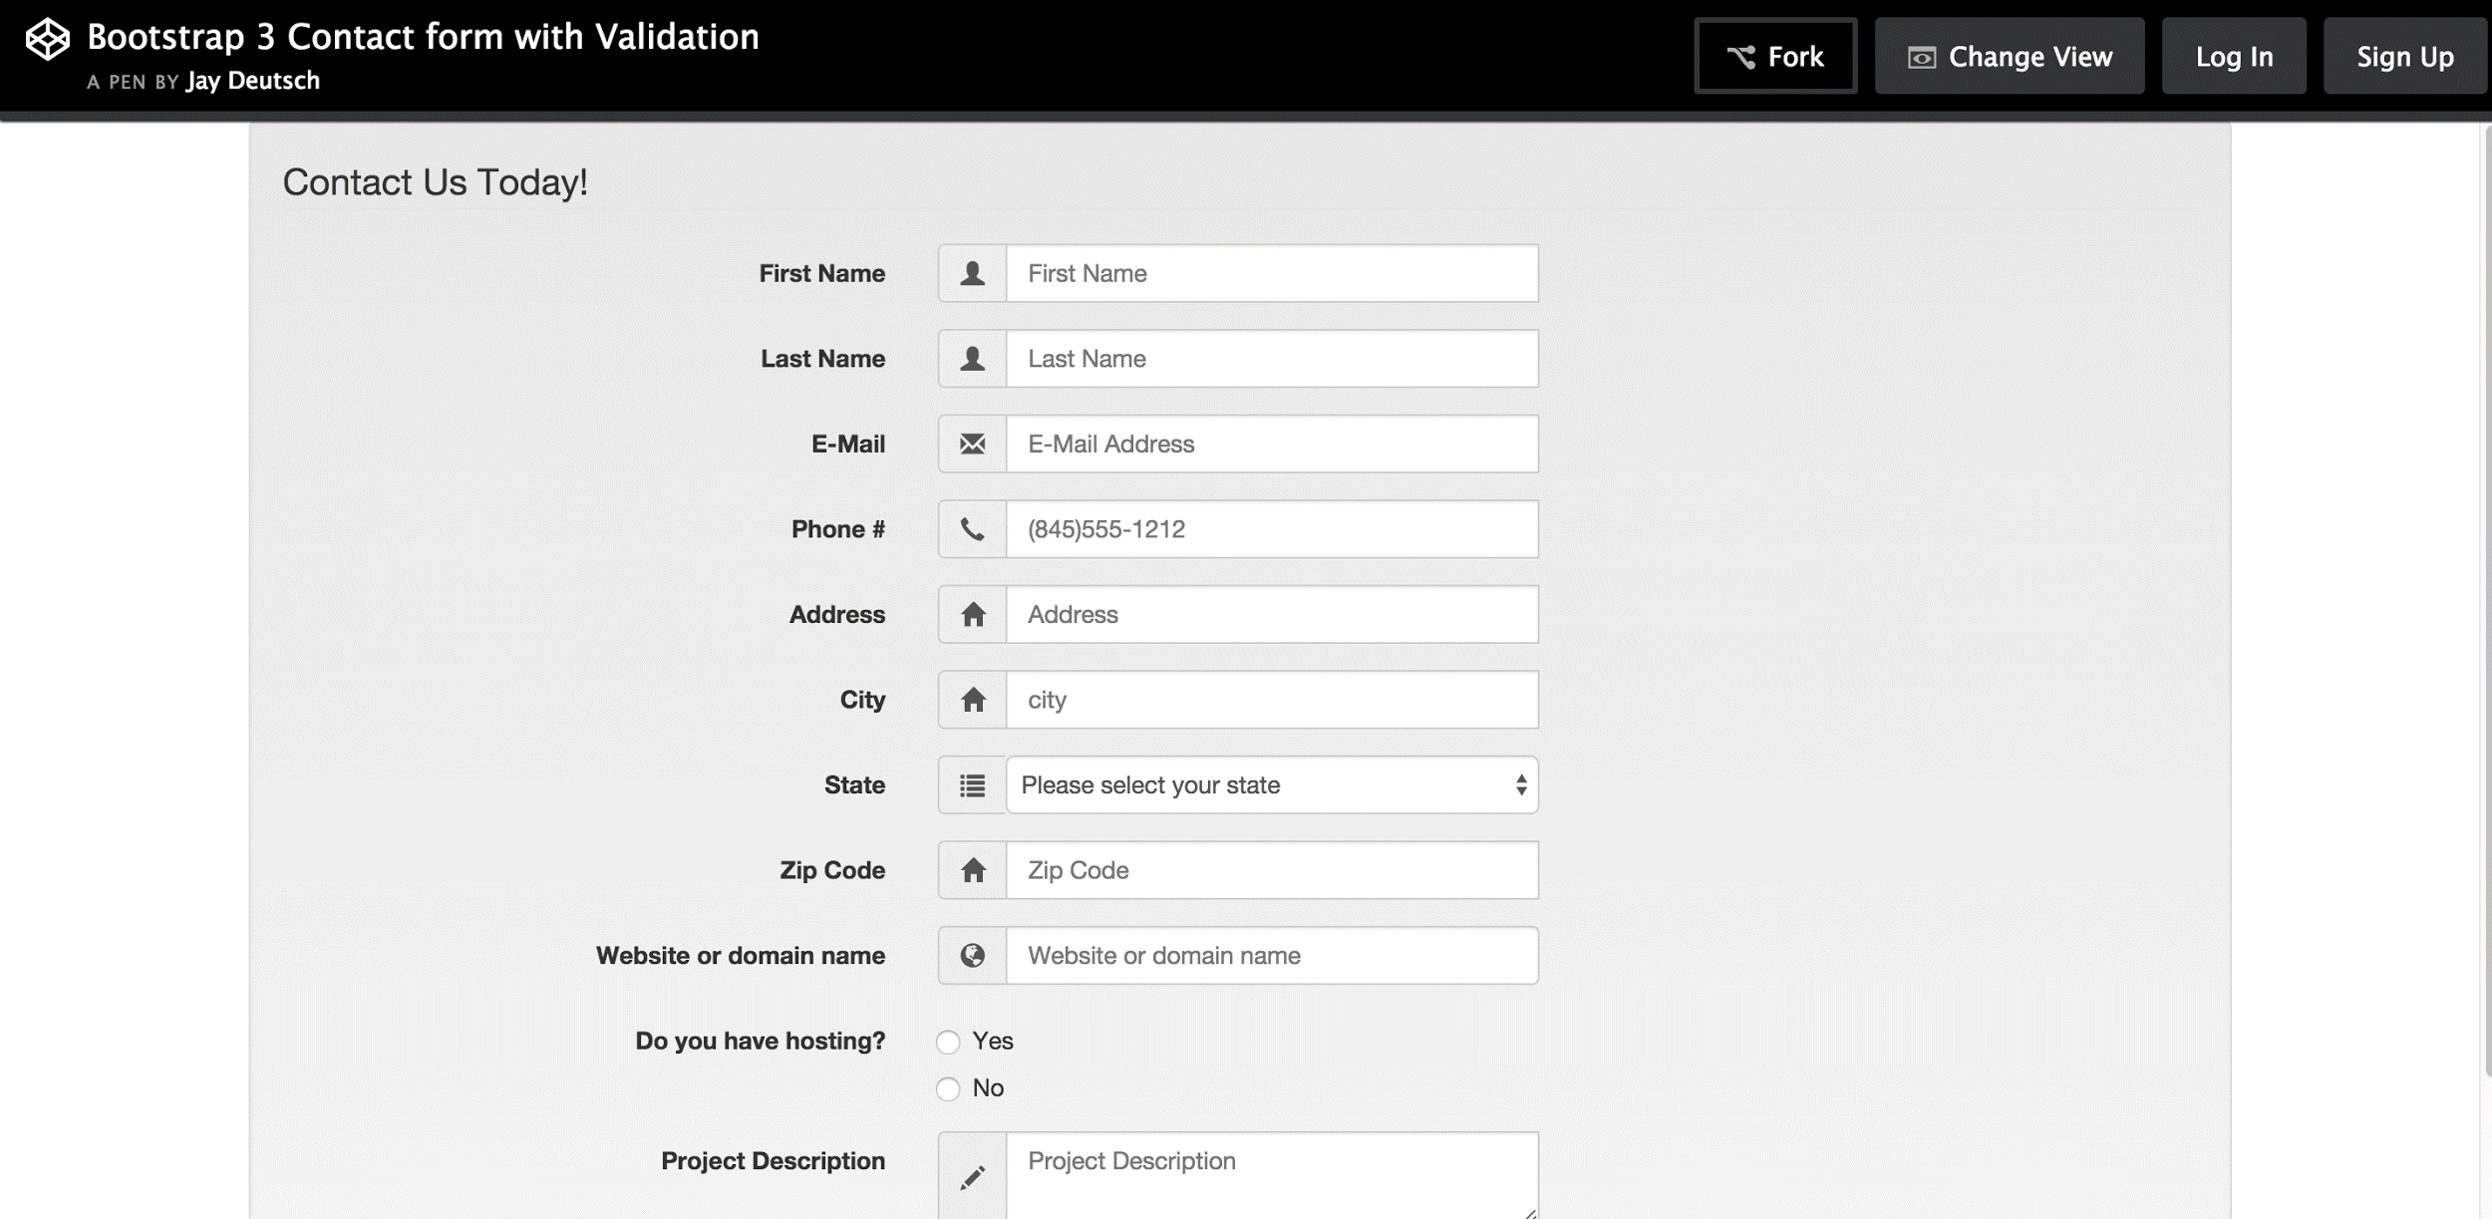

Bootstrap offers so many different elements like icons, font types, form fields that it would be a shame not to have a proper contact form built using this front-end framework. Jay Deutsch understands this and brings out a very complex contact form that takes advantage of every single Bootstrap element that could be used for building a professional contact form. This one, in particular, has been built for agencies and businesses who want to collect online business through a single form, so expect to be able to collect information like full address of the person reaching out, their phone number, and their concise description of the project they are looking to fulfill.

[Download](http://codepen.io/jaycbrf/pen/iBszr/)

## **Elegant Contact Form**

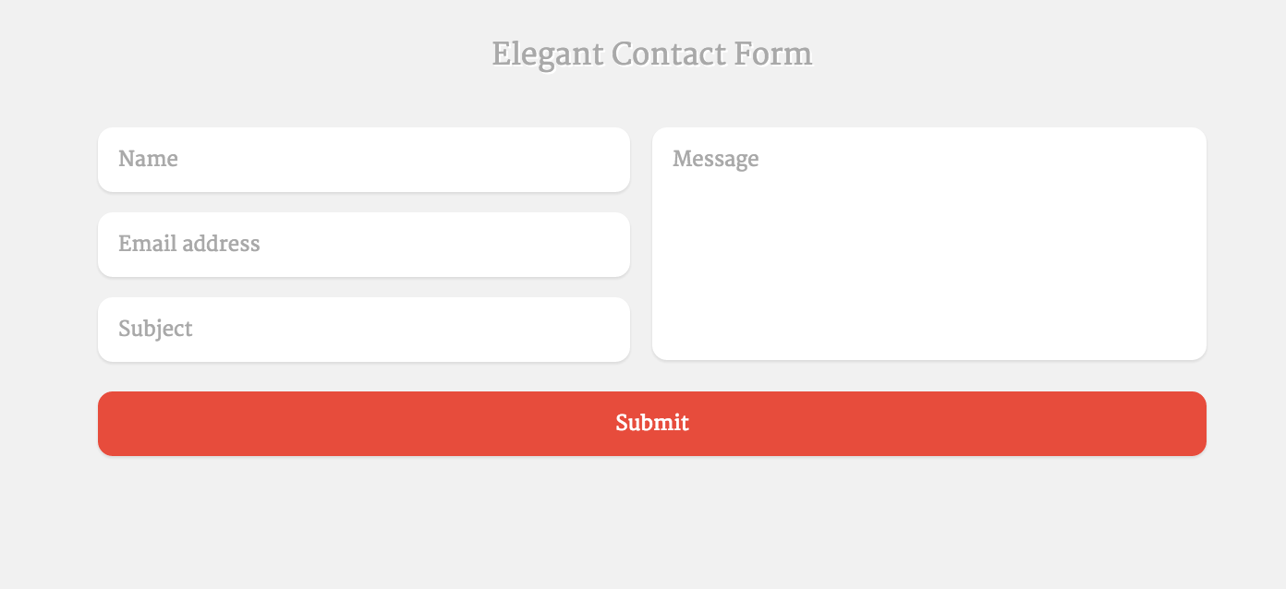

This elegant form comes from Mark Murray, who is using the Compass framework to unfold a very modern contact form experience that utilizes the left and right design aspects. Left for contact details, and right for the actual contact message. It has been crafted with a transparent background, but with a few modifications you should be able to adjust this contact form to work with any color scheme out there. Another thing about these forms is that it is so easy to add your own custom form field types, all you need to do is code the proper server-side script to be able to process those field types.

[Download](http://codepen.io/markmurray/pen/JsAhx/)

## **Clean Contact Form**

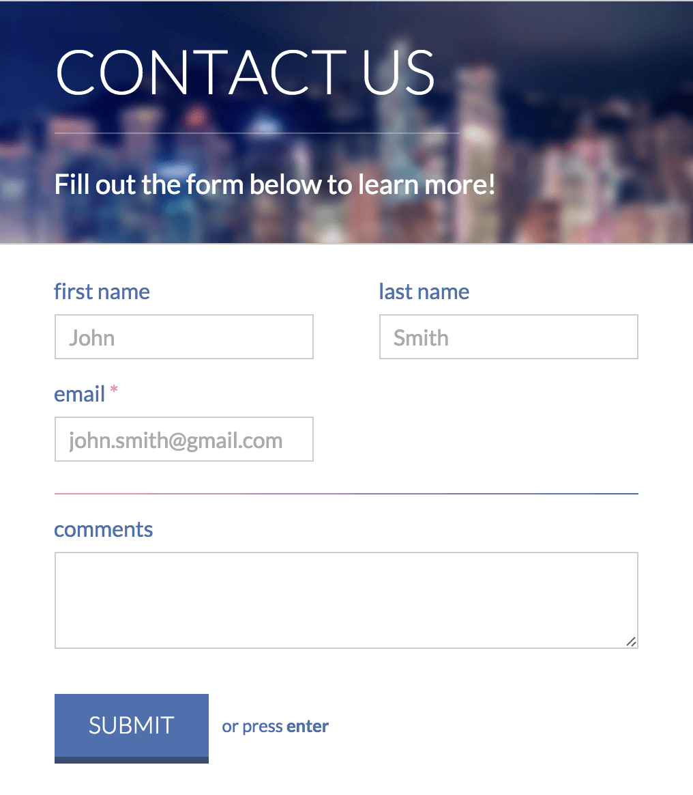

This clean version of a contact form is coming from Nick Haskell, he is also relying on the amazing capabilities of the Compass framework to reveal a unique forms experience. The biggest feature of this one is that it uses a background image for the top of the form, allowing you to make it seem more visually appealing, and in many ways more professional. The code is written clearly and is easy to understand as well as modify.

[Download](http://codepen.io/nickhaskell/pen/HoGsm)

## **Under the Sea Contact Form**

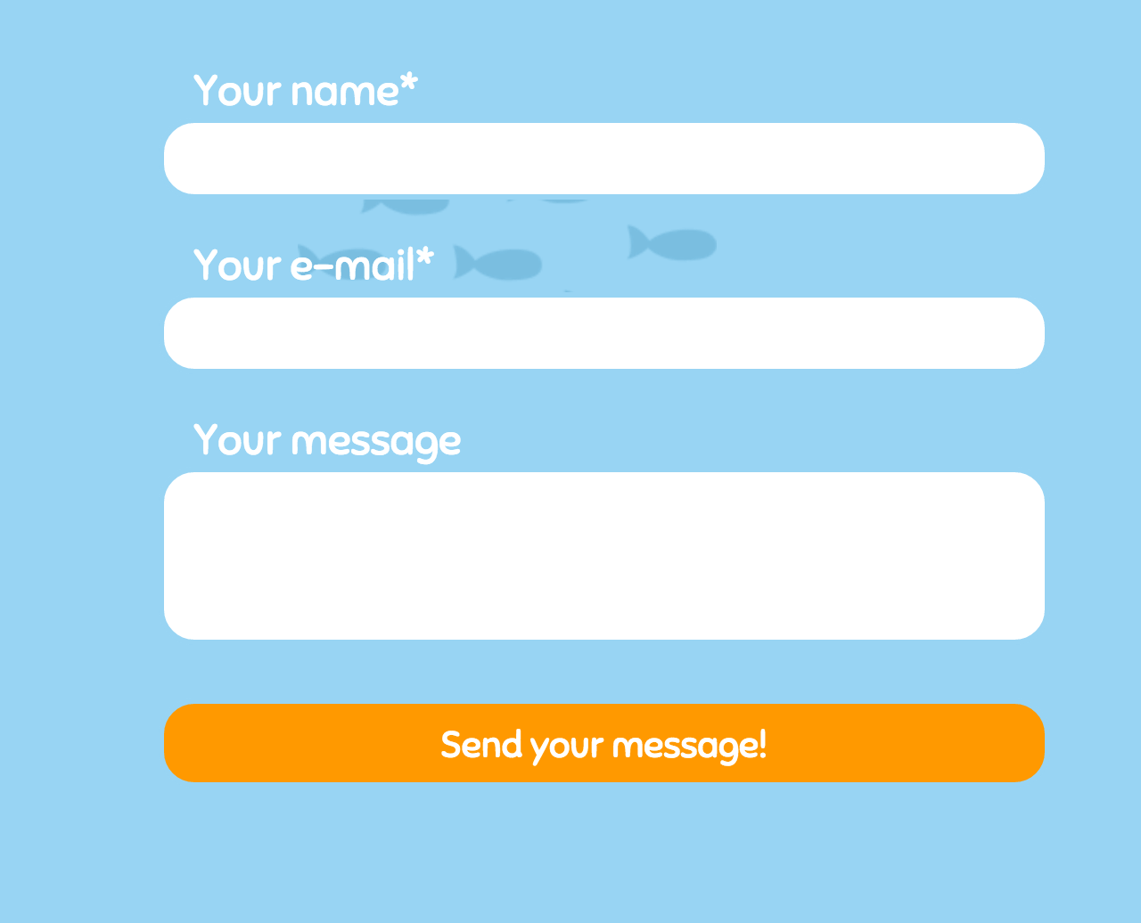

An anonymous CodePen user has submitted what might be the most beautiful and interactive contact form on our list. This ‘Under the Sea’ form is a full-page contact form that extends on JavaScript and CSS3 to provide a very beautiful animated contact form experience that will suit sites the kind of children’s interests, animation, graphic design, or other interactive types of websites that want to establish that ‘wow factor’. The design, the use of fonts, and the actual consistent animation is going to be hard to resists even for the average blogger.

[Download](http://codepen.io/anon/pen/OMMOaO/)

## **Responsive Contact Form with Map**

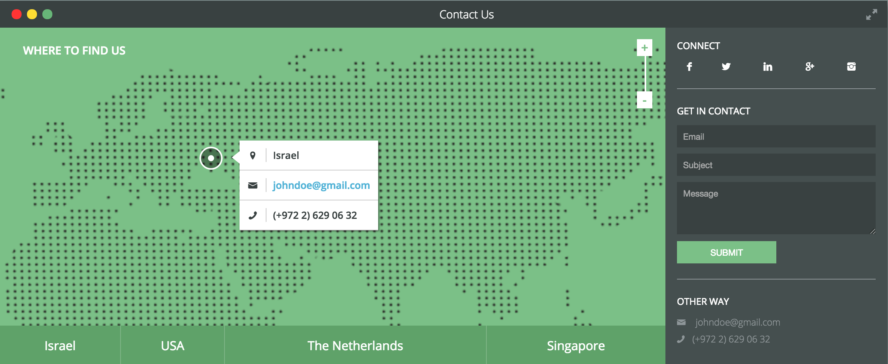

Lentie Ward is an amazing designer who is using the latest Haml and SCSS technologies (with a hint of JavaScript) to build what may be the most sophisticated contact form in the available free market. This form is more like a full-scale personal contact database for a business that also operates in physical locations. With the help of JavaScript, visitors are quickly able to jump between different physical locations of your business within the in-built Google Maps widget, while the right side of the widget is for displaying social media information, the actual contact form, and there’s also space for contact details in text form. Truly a spectacular way of allowing your visitors to reach out to you.

[Download](http://codepen.io/lentilz/pen/ivhcx/)

## **Contact Form Bootstrap 3**

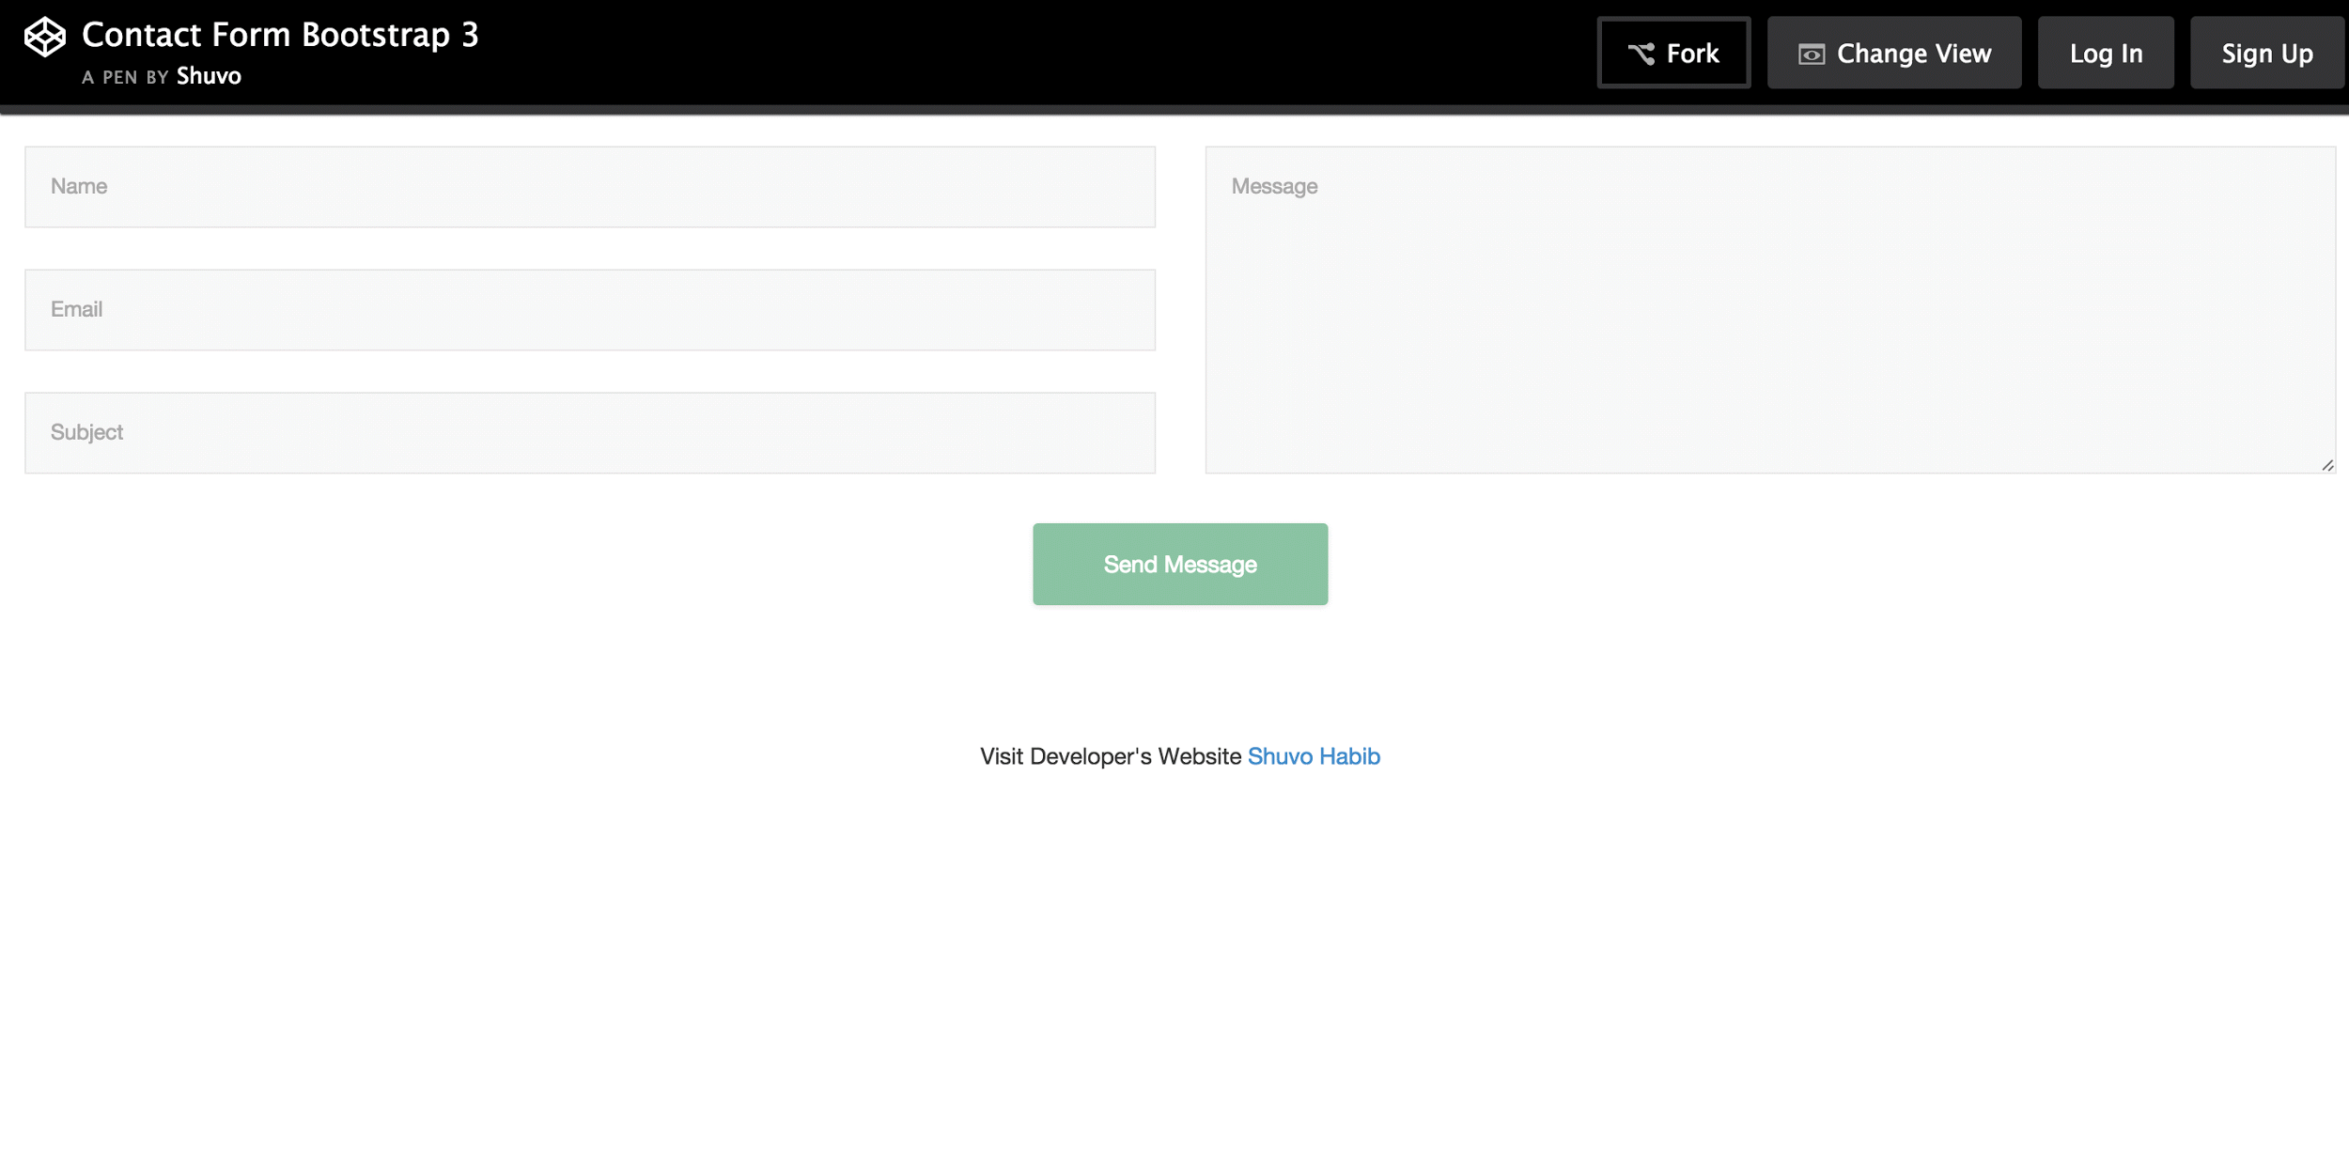

Lets take a peek at another Bootstrap form, this time coming from Shuvo Habib. There really isn’t much to say about this one, other than it is a full-width form that will collect the basic required information from your visitors and post it to your email address in the way you want to receive it.

[Download](http://codepen.io/ShuvoHabib/pen/enzqb/)

## **Responsive Contact Form**

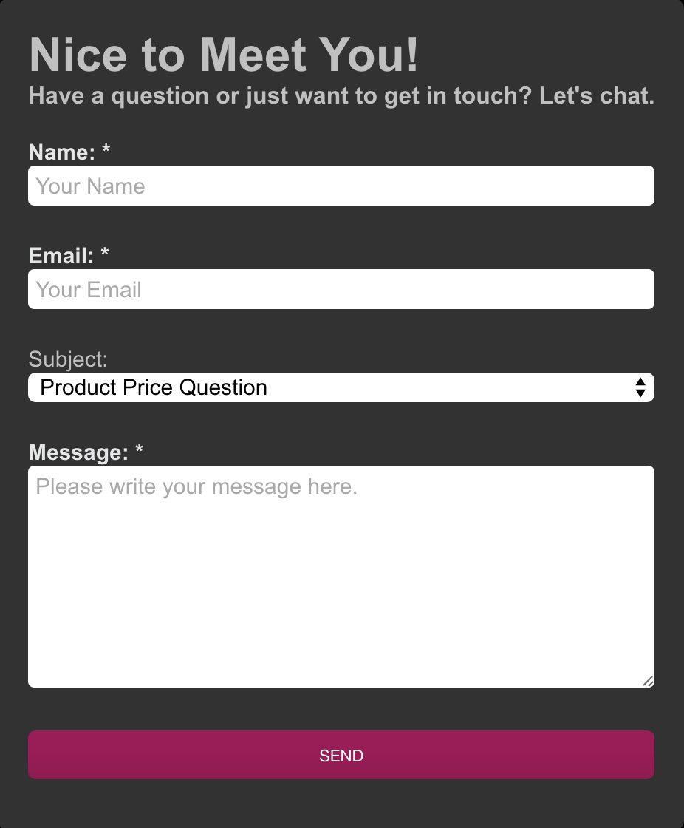

Lisa Wagner has an idea for a good looking contact form. This mobile-optimized form uses boxed layout with a special feature ‘dropdown’. The dropdowns can be specified to help you better categorize the emails that you are receiving, and in turn either allocate them priority or just have a better understanding of the kind of support people are seeking the most, and then perhaps provide different support alternatives in that area. The colors are quite dark with this one, but all of that can be changed using basic CSS knowledge.